
Company
Logotype

Cone Beam Computed Tomography- Report



Porur Dental X-rays & CBCT

Patient Name : Mr. Sinoj | Date of Report : 16.06.2024
Age/ Gender : 41 years/ Male | Region of Interest : CBCT Sectional Mandible
Referring doctor: Dr. Metilda | Indication : Bone expansion ?
Clinical Notes: Nil
PATIENT INFORMATION

CBCT- Sectional Mandible provided
CBCT – IMAGE DETAILS

RADIOGRAPHIC INTERPRETATION

- In relation to 36, 38, presence of hyperdense restorative material involving the enamel and dentin is evident.
- In relation to the inter- radicular region of 35, 36 presence of a hypodense region extending from 1.77 mm below the alveolar ridge upto the apical third of 35, 36 also involving their distal and medial root surfaces respectively.
- In relation to 36- mesial root, presence of a mild hypodense transverse line running from buccal to palatal aspect is evident.

RADIOGRAPHIC IMPRESSION

- Chronic periodontitis: 36
- Periodontal abscess: between 35, 36

[Note: Suggested to take an IOPA of 36 and perform Pulp testing of 36]

Kindly correlate with clinical findings


IMAGES FOR REFERENCE

RECONSTRUCTED PANORAMIC VIEW

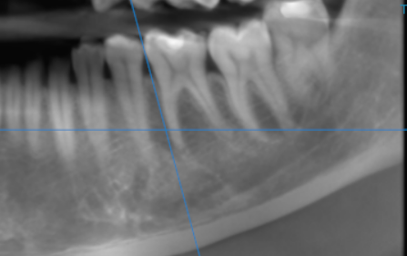

3-DIMENSIONAL VIEW

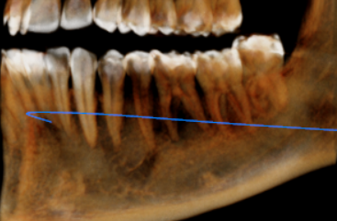

CROSS SECTIONAL VIEW

35, 36 region

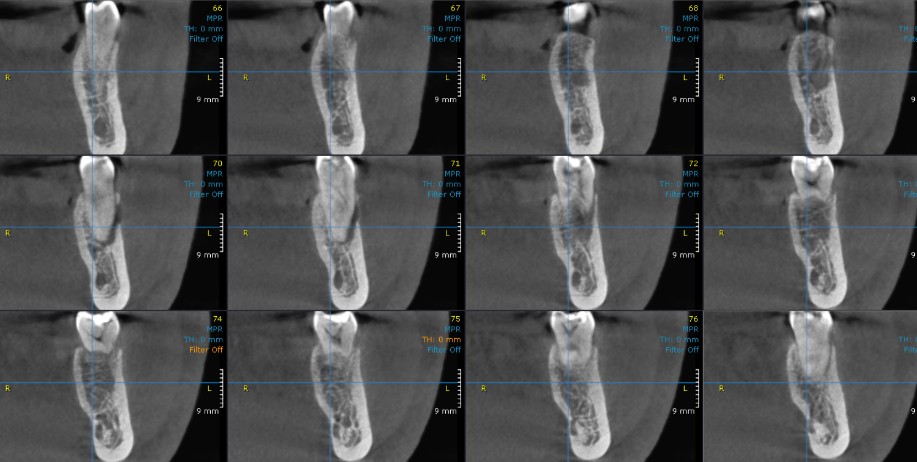

CROSS SECTIONAL VIEW- Presence of a hypodense transverse line in relation to the mesial root.

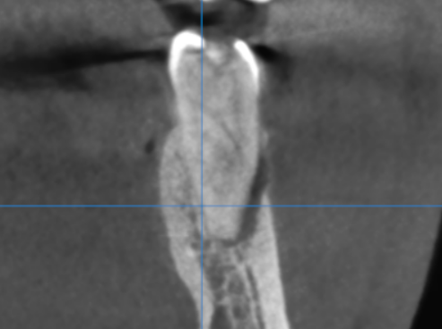

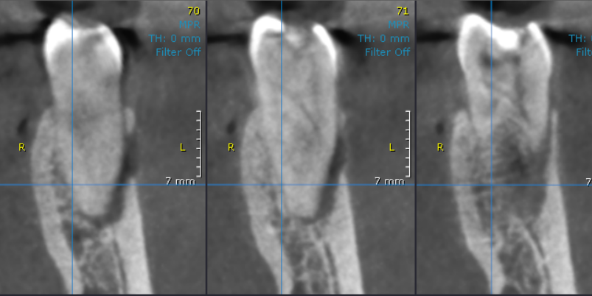

**** End of report ****

